Question 1
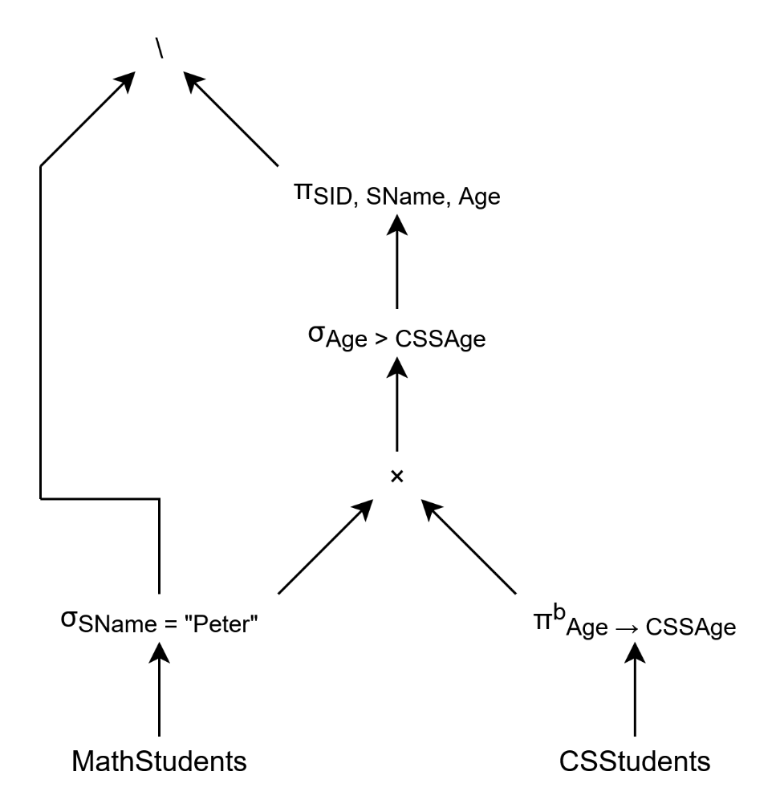
The tree above is the one I came up with. Note that the order for the set difference operator matters, and that the whole tree is equivalent to: $σ_{SName = "Peter"}\left(MathStudents\right) \backslash$$$\backslash π_{SID,SName,Age}\left(σ_{Age > CSSAge}\left(σ_{SName = "Peter"}\left(MathStudents\right)×π_{Age → CSSAge}^{b}\left(CSStudents\right)\right)\right)$$
Question 2
Part a.
$${Relation}/{Statistics}$$ | $$Size\left(R\right)$$ | $$Tups\left(R\right)$$ | $$TupSize\left(R\right)$$ | $$Vals\left(R.X\right)$$
MathStudents | $$3*50=150$$ | 3 | $$10+30+10=50$$ | $$X=SID:3$$  $$X=SName:2$$  $$X=Age:2$$
CSStudents | $$3*50=150$$ | 3 | $$10+30+10=50$$ | $$X=SID:2$$  $$X=SName:2$$  $$X=Age:3$$
Takes | $$3*40=120$$ | 3 | $$10+30=40$$ | $$X=SID:2$$  $$X=Course:2$$
Above is the table of statistics requested of each of the relations for the cost function.
P.S. all the formulas and methods used in both part a and part b are taken from lecture 13.
Part b.
The cost function is the sum of the sizes after each operation of the whole expression. So the whole process becomes: $TotalCost=Size\left(σ_{SName=”Julia” }\left(MathStudents\right)\right)+Size\left(σ_{SName=”Julia” }\left(MathStudents\right)∩CSStudents\right)+Size\left(\left(σ_{SName=”Julia” }\left(MathStudents\right)∩CSStudents\right)⋈Takes\right)$
Notice the propagation, for easier visualization purposes we will compute each one separately and use the previous steps in the next ones, then sum it all up in the end.
- $Size\left(σ_{SName=”Julia” }\left(MathStudents\right)\right)=$$$=Tups\left(σ_{SName=”Julia” }\left(MathStudents\right)\right)*TupSize\left(MathStudents\right)= \\ =\frac{Tups\left(MathStudents\right)}{Vals\left(MathStudents. SName\right)}*TupSize\left(MathStudents\right)=\frac{3}{2}*50=1.5*50=75$$
- $Size\left(σ_{SName=”Julia” }\left(MathStudents\right)∩CSStudents\right)=$$$=Tups\left(σ_{SName=”Julia” }\left(MathStudents\right)∩CSStudents\right)*TupSize\left(CSStudents\right)= \\ =\frac{\min\left(Tups\left(σ_{SName=”Julia” }\left(MathStudents\right)\right), Tups\left(CSStudents\right)\right)}{2}*TupSize\left(CSStudents\right)=$$$=\frac{\min\left(1.5,3\right)}{2}*50=\frac{1.5}{2}*50=0.75*50=37.5$, note that $TupSize\left(CSStudents\right)=TupSize\left(σ_{SName=”Julia” }\left(MathStudents\right)\right)$ must hold due to $∩$ operator.
- For this one we need $Vals\left(\left(σ_{SName=”Julia” }\left(MathStudents\right)∩CSStudents\right).SID\right)$ which we did not keep track of, so let’s catch up and compute it now:
$$Vals\left(\left(σ_{SName=”Julia” }\left(MathStudents\right)∩CSStudents\right). SID\right)= \\ =\frac{\min\left(Vals\left(σ_{SName=”Julia” }\left(MathStudents\right).SID\right),Vals\left(CSStudents.SID\right)\right)}{2}= \\ =\frac{\min\left(\frac{Vals\left(MathStudents. SID\right)*Tups\left(σ_{SName=”Julia” }\left(MathStudents\right)\right)}{Tups\left(MathStudents\right)},Vals\left(CSStudents.SID\right)\right)}{2}=$$$=\frac{\min\left(\frac{3*1.5}{3},2\right)}{2}=\frac{\min\left(1.5,2\right)}{2}=\frac{1.5}{2}=0.75$. Now we can continue and compute the size. $Size\left(\left(σ_{SName=”Julia” }\left(MathStudents\right)∩CSStudents\right)⋈Takes\right)=$$$=Tups\left(\left(σ_{SName=”Julia” }\left(MathStudents\right)∩CSStudents\right)⋈Takes\right)* \\ *TupSize\left(\left(σ_{SName=”Julia” }\left(MathStudents\right)∩CSStudents\right)⋈Takes\right)= \\ =\frac{Tups\left(σ_{SName=”Julia” }\left(MathStudents\right)∩CSStudents\right)*Tups\left(Takes\right)}{\max\left(Vals\left({(σ}_{SName=”Julia” }\left(MathStudents\right)∩CSStudents).SID\right),Vals(Takes.SID)\right)}* \\ *\left(TupSize\left(\left(σ_{SName=”Julia” }\left(MathStudents\right)∩CSStudents\right)\right)+TupSize\left(Takes\right)-Size\left(SID\right)\right)= \\ =\frac{0.75*3}{\max\left(0.75,2\right)}*\left(TupSize\left(CSStudents\right)+TupSize\left(Takes\right)-Size\left(SID\right)\right)=$$$=\frac{2.25}{2}*\left(50+40-10\right)=90$. Note that $Size\left(SID\right)=Size of value in B=10$.
So, the $TotalCost=75+37.5+90=$ $202.5$.
Question 3
Part a.
$$BlockSize=8000B, TupSize=300B, SearchKeySize=20B, PointerSize=4B$$
The blocks are continuous which means that we don’t need to save information on where the next block corresponding to the same table is, if there is any (unlike in a linked version where we do have that). Since it is unspanned as well, if we can’t fit an entire tuple into a block, we try out the next one, and so on… So basically, we look at how many tuples a block can fit (unlike in spanned version where we would need to consider individual attributes).
An index consists of blocks of entries where each entry is made up of a $SearchKey$ and a $Pointer$ which means that its size is: $EntrySize=SearchKeySize+PointerSize=20B++ 4B=24B$. A single block of entries contains $EntriesPerBlock=\left\lfloor \frac{BlockSize}{IndexSize}\right\rfloor =\left\lfloor \frac{8000B}{24B}\right\rfloor ==333$. Note that the floor function is there because the blocks are unspanned.
Because we compare by the least amount of block access done in worst-case scenarios, first we need to know the number of reads that the one-level dense index, which we will call $A$ for short, needs, and that is $Reads_{A}=\left\lceil \frac{Tuples}{EntriesPerBlock^{Levels}}\right\rceil +Levels=\left\lceil \frac{Tuples}{{333}^{1}}\right\rceil +1$ where $Tuples$ represents the number of tuples that our relation table has. Also, we add $Levels$ which is $1$ because after reading the first level, which is a dense index block, we need to access the block where the tuple data is actually stored. However, that detail only holds for when $Tuples>0$, because otherwise there is no index. Next, the number of reads that the two-level index, with second-level sparse and first-level dense, which we will call $B$, has $Reads_{B}=\left\lceil \frac{Tuples}{EntriesPerBlock^{Levels}}\right\rceil +Levels=\left\lceil \frac{Tuples}{{333}^{2}}\right\rceil +2$ for when $Tuples>0$. The reason behind it is identical to that of $+1$ in $Reads_{A}$, it’s just a tree of greater depth, namely: $2$.
Now, to find out when $B$ is faster than $A$ we calculate at what number of $Tuples$does $Reads_{A}>Reads_{B}$ hold, which we assume it will after $Tuples$ crosses a certain threshold.
$$1) Reads_{A}>Reads_{B}, 2) \left\lceil \frac{Tuples}{{333}^{1}}\right\rceil +1>\left\lceil \frac{Tuples}{{333}^{2}}\right\rceil +2, 3) \left\lceil \frac{Tuples}{333}\right\rceil +1-\left\lceil \frac{Tuples}{{333}^{2}}\right\rceil >2, \\ 4) \left\lceil \frac{Tuples}{333}\right\rceil >2, 5) Tuples>2⋅333, 6) Tuples>666$$
So, the threshold for when the two-level index with 1st level dense and 2nd level sparse is more efficient than the one-leveled dense index is when the number of $Tuples$ is above $666$ which is basically $667$ or more.
Part b.
Here we use similar formulas as in part a, so I won’t cover these here. Also, note that the constant $EntriesPerBlock$ has not changed, i.e. its value is identical to the one in part a. Now, Let’s call the one-level sparse index $A$, and the two-level sparse index $B$. Since the first level in both of these is sparse, we must use $\frac{Tuples}{TuplesPerBlock}$ instead of just $Tuples$ where $TuplesPerBlock=\left\lfloor \frac{BlockSize}{TupSize}\right\rfloor =\left\lfloor \frac{8000B}{300B}\right\rfloor =26$. That is because unlike in a first-level dense index where each entry points to each tuple, i.e. a block and an offset within that block, each entry in a first-level sparse index points to the first tuple within a block which can hold multiple $Tuples$ at once. Thus, the slightly modified formula for the number of reads is:
$Reads_{A}=\left\lceil \frac{\frac{Tuples}{TuplesPerBlock}}{EntriesPerBlock^{Levels}}\right\rceil +Levels=\left\lceil \frac{\frac{Tuples}{26}}{{333}^{1}}\right\rceil +1$ for $A$ where $Tuples>0$, and $Reads_{B}=\left\lceil \frac{\frac{Tuples}{TuplesPerBlock}}{EntriesPerBlock^{Levels}}\right\rceil +Levels=\left\lceil \frac{\frac{Tuples}{26}}{{333}^{2}}\right\rceil +2$ for $B$ where $Tuples>0$.
Now, we find out when $Reads_{A}>Reads_{B}$, i.e. when $A$ is less efficient than $B$:
$$1) Reads_{A}>Reads_{B}, 2) \left\lceil \frac{\frac{Tuples}{26}}{{333}^{1}}\right\rceil +1>\left\lceil \frac{\frac{Tuples}{26}}{{333}^{2}}\right\rceil +2, 3) \left\lceil \frac{\frac{Tuples}{26}}{333}\right\rceil +1-\left\lceil \frac{\frac{Tuples}{26}}{{333}^{2}}\right\rceil >2, \\ 4) \left\lceil \frac{\frac{Tuples}{26}}{333}\right\rceil >2, 5) Tuples>2⋅333⋅26, 6) Tuples>17316$$
So, the threshold for when the two-level index with both levels sparse is more efficient than the one-leveled sparse index is when the number of $Tuples$ is above $17316$ which is basically $17317$ or more.

